**CODING CONTEST - 1**

**727721EUIT091**

**MOHAMED ASHIF A**

**QUESTION 1:**

**CODE**

**package** CC1;

**import** org.openqa.selenium.By;

**import** org.openqa.selenium.Keys;

**import** org.openqa.selenium.WebDriver;

**import** org.openqa.selenium.WebElement;

**import** org.openqa.selenium.chrome.ChromeDriver;

**import** org.openqa.selenium.chrome.ChromeOptions;

**import** io.github.bonigarcia.wdm.WebDriverManager;

**public** **class** qn1 {

**public** **static** **void** main(String []args) {

WebDriverManager.*chromedriver*().setup();

WebDriver driver;

ChromeOptions fo = **new** ChromeOptions();

fo.addArguments("--remote-allow-origins=*");

driver = **new** ChromeDriver(fo);

driver.get("https://www.saucedemo.com/");

WebElement wb1=driver.findElement(By.*id*("user-name"));

wb1.sendKeys("standard_user"+Keys.***ENTER***);

WebElement wb2=driver.findElement(By.*id*("password"));

wb2.sendKeys("secret_sauce"+Keys.***ENTER***);

WebElement wb3=driver.findElement(By.*id*("login-button"));

wb3.submit();

WebElement wb5 =driver.findElement(By.*xpath*("//*[@id=\"add-to-cart-sauce-labs-bike-light\"]"));

wb5.click();

WebElement wb6 =driver.findElement(By.*xpath*("//*[@id=\"shopping_cart_container\"]/a"));

wb6.click();

WebElement wb7 =driver.findElement(By.*id*("checkout"));

wb7.click();

WebElement fname= driver.findElement(By.*id*("first-name"));

fname.sendKeys("mohammed ashif");

WebElement lname= driver.findElement(By.*id*("last-name"));

lname.sendKeys("a");

WebElement code= driver.findElement(By.*id*("postal-code"));

code.sendKeys("1234");

WebElement conti =driver.findElement(By.*id*("continue"));

conti.click();

WebElement wb8 =driver.findElement(By.*xpath*("//*[@id=\"item_0_title_link\"]/div"));

String pname=wb8.getText();

WebElement wb9 =driver.findElement(By.*xpath*("//*[@id=\"checkout_summary_container\"]/div/div[1]/div[3]/div[2]/div[2]"));

String price=wb9.getText();

System.***out***.println("Product : "+pname);

System.***out***.println("Price : "+price);

String title=driver.getTitle();

String url=driver.getCurrentUrl();

**if**(title.equals("Swag Labs"))

System.***out***.println("Title Verified Successfully");

**else**

System.***out***.println("Title Not Verified");

**if**(url.equals("https://www.saucedemo.com/checkout-step-two.html"))

System.***out***.println("URL Verified Successfully");

**else**

System.***out***.println("URL Not Verified");

}

}

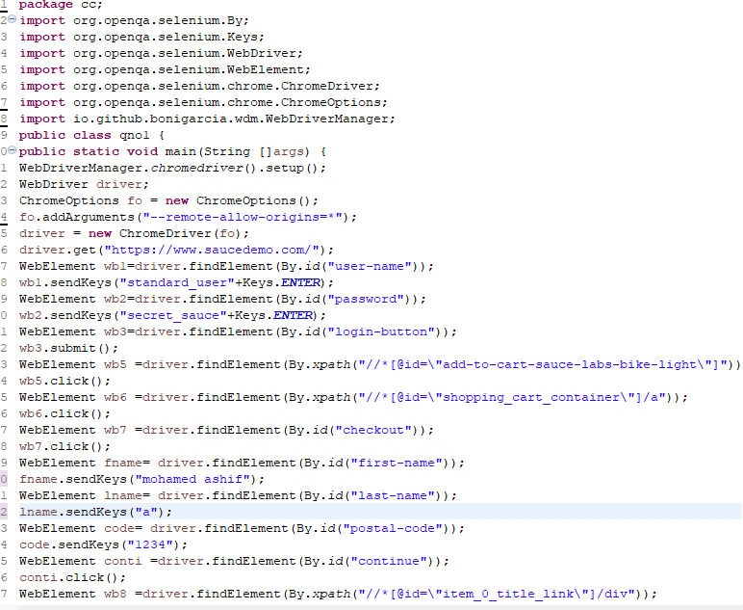

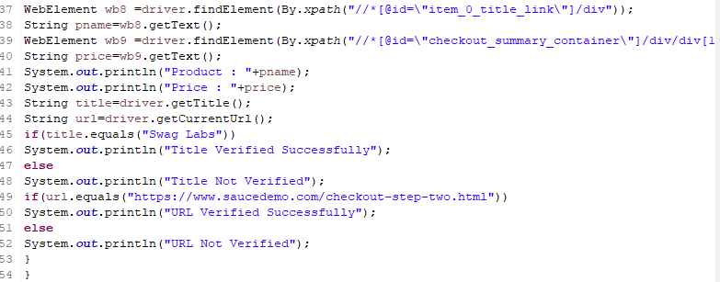

**OUTPUT:**

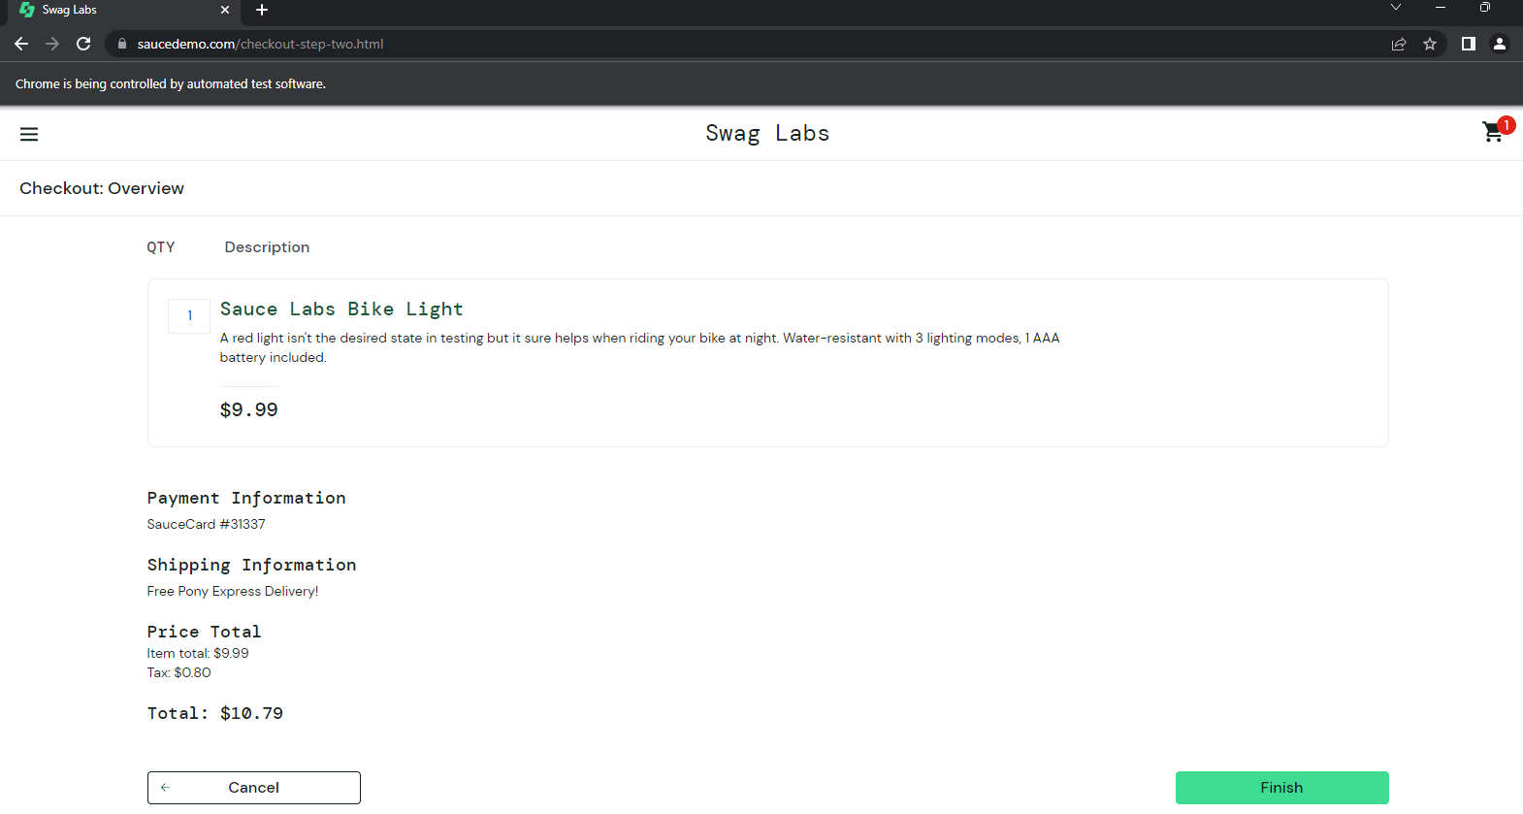

**QUESTION 2:**

**CODE:**

**package** CC1;

**import** org.openqa.selenium.By;

**import** org.openqa.selenium.Keys;

**import** org.openqa.selenium.WebDriver;

**import** org.openqa.selenium.WebElement;

**import** org.openqa.selenium.chrome.ChromeDriver;

**import** org.openqa.selenium.chrome.ChromeOptions;

**import** org.openqa.selenium.support.ui.Select;

**import** io.github.bonigarcia.wdm.WebDriverManager;

**public** **class** qn2 {

**public** **static** **void** main(String []args) {

WebDriverManager.*chromedriver*().setup();

WebDriver driver;

ChromeOptions fo = **new** ChromeOptions();

fo.addArguments("--remote-allow-origins=*");

driver = **new** ChromeDriver(fo);

driver.get("https://www.saucedemo.com/");

WebElement wb1=driver.findElement(By.*id*("user-name"));

wb1.sendKeys("standard_user"+Keys.***ENTER***);

WebElement wb2=driver.findElement(By.*id*("password"));

wb2.sendKeys("secret_sauce"+Keys.***ENTER***);

WebElement wb3=driver.findElement(By.*id*("login-button"));

wb3.submit();

WebElement sort1=driver.findElement(By.*xpath*("//*[@id=\"header_container\"]/div[2]/div/span/select"));

Select select1=**new** Select(sort1);

select1.selectByValue("za");

WebElement name1=driver.findElement(By.*xpath*("//*[@id=\"item_3_title_link\"]/div"));

String txt1=name1.getText();

System.***out***.println("1st Product After Z-A Filter"+txt1);

WebElement sort2=driver.findElement(By.*xpath*("//*[@id=\"header_container\"]/div[2]/div/span/select"));

Select select2=**new** Select(sort2);

select2.selectByValue("lohi");

WebElement name2=driver.findElement(By.*xpath*("//*[@id=\"item_2_title_link\"]/div"));

String txt2=name2.getText();

System.***out***.println("1st Product After Low-High Filter"+txt2);

WebElement sort3=driver.findElement(By.*xpath*("//*[@id=\"header_container\"]/div[2]/div/span/select"));

Select select3=**new** Select(sort3);

select3.selectByValue("hilo");

WebElement name3=driver.findElement(By.*xpath*("//*[@id=\"item_5_title_link\"]/div"));

String txt3=name3.getText();

System.***out***.println("1st Product After High-Low Filter"+txt3);

}

}

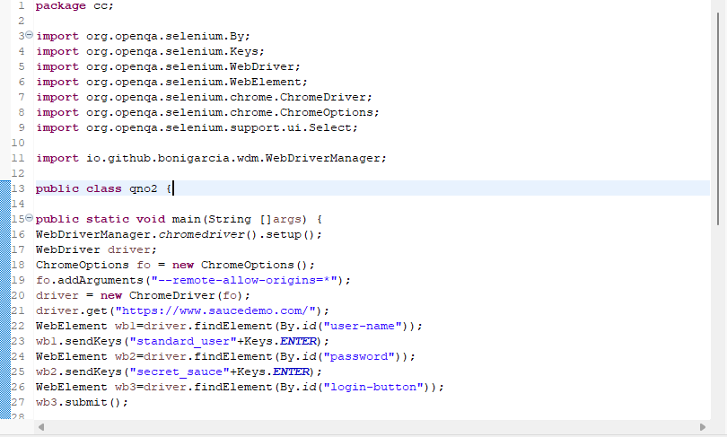

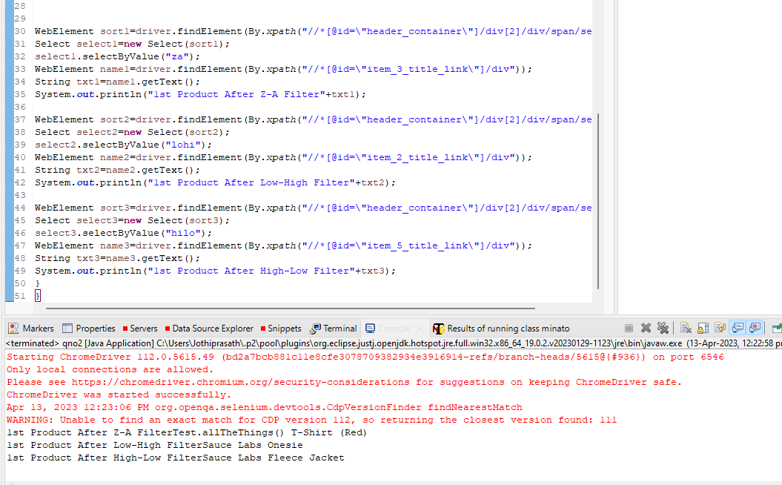

**OUTPUT:**

